IFM OS
V1 Frontend Redesign Brief
Visual storyboard + product direction + iterative design-agent instructions
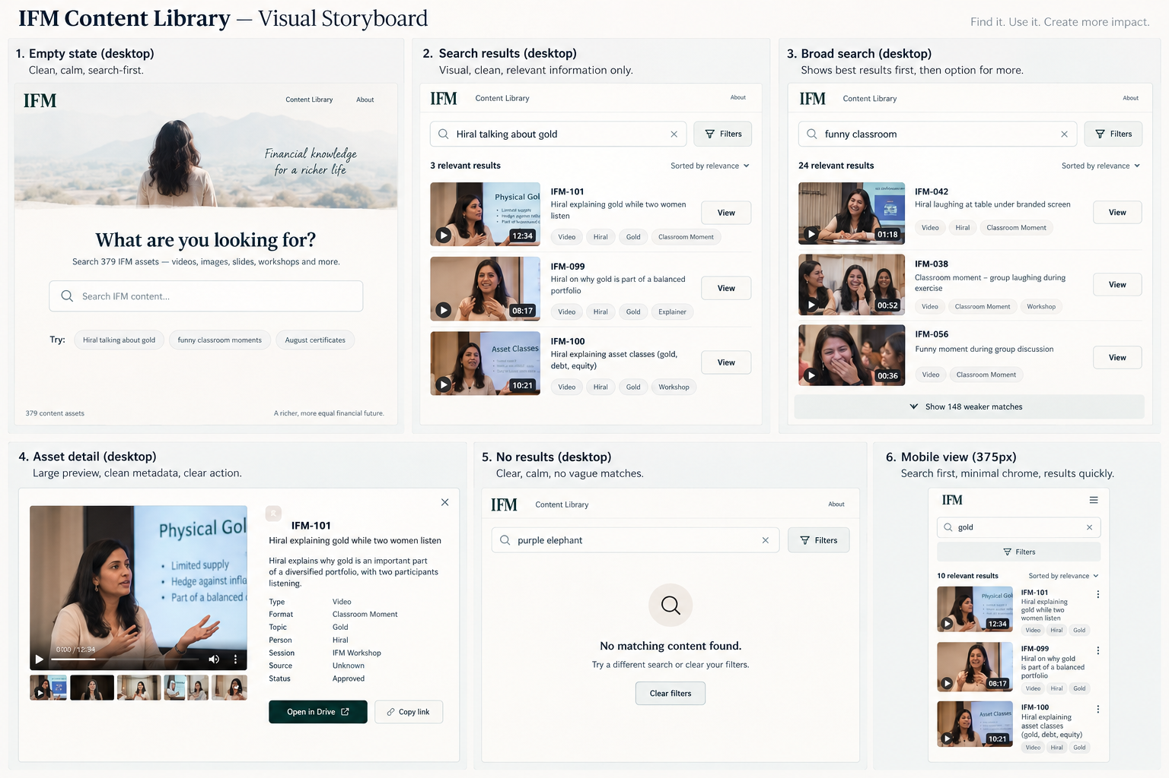
ATTACH THIS DOCUMENT TO CLAUDE. The storyboard image is embedded in this file.

1. Product Direction
The current backend, search engine, classifier, enrichment pipeline and 379-asset dataset are validated. This phase is a FRONTEND REDESIGN. Do not rebuild the underlying system.

The product
Think of this as the IFM content operating system — with the Library as its most important daily experience.
- Aakara needs a piece of IFM content.
- She describes what she remembers in natural language.
- The system finds the relevant assets.
- She visually confirms the correct asset.
- She previews it.
- She opens the actual Drive file.
- She does not need Sakshi.

What this is NOT
- Not a DAM dashboard
- Not an analytics dashboard
- Not a CMS
- Not a project-management tool
- Not a content calendar
- Not an admin console
- Not a database interface

Visual character
Premium, editorial, calm, intelligent, minimal, content-first, confident, generous with whitespace.
Avoid: generic SaaS dashboard aesthetics, excessive cards/pills/borders, colourful dashboards, gradients/glows, developer UI, excessive filters, AI gimmicks and visual clutter.

2. Visual Storyboard — Six States
The embedded storyboard on the cover is the visual north star. Use it for hierarchy, density, whitespace, thumbnail scale, metadata treatment and desktop/mobile composition. Do not copy it mechanically.

1. Empty Library — Desktop
Primary message: “What are you looking for?” Search is the dominant interaction. Show only a few subtle examples such as “Hiral talking about gold”, “funny classroom moments”, and “August certificates”. Avoid a wall of chips. Generous whitespace.

2. Focused Search — Desktop
Example: “Hiral talking about gold”. Collapse the empty-state hero. Show the query, a compact Filters control, result count, then visually identifiable result rows. Use real thumbnails.

3. Broad Search — Desktop
Example: “funny classroom”. Show strong/relevant results first. If weaker results exist, expose them behind “Show weaker matches”. Do not dump 172 results into the user’s face.

4. Asset Detail — Desktop
Large media preview, inline video where applicable, restrained metadata, one obvious primary action: Open in Drive. Preserve the existing strong detail functionality.

5. No Results — Desktop
Example: “purple elephant”. Calm message: “No matching content found.” Offer a different search or Clear filters. Never return vaguely related content.

6. Mobile — 375px
Search first, Filters second, Results immediately. No giant intro, developer banner, nine example chips or six visible dropdowns. Design mobile intentionally, not as compressed desktop.

3. Full Claude Implementation Brief

A. Freeze the validated backend
- Do not change taxonomy, 379-asset dataset, classifier, enrichment, search engine, IDF/ranking foundations, word-boundary matching, constraint logic, relevance logic, Drive integration, asset detail data, inline preview capability or no-server architecture.
- If a frontend change appears to require a backend change, STOP and report it rather than casually modifying the validated system.
- Live hub must remain untouched. Work only in CLAUDE/content/v1-prototype/.

B. Search is the main interface
- Natural-language search is the default. Users should be able to type: gold; Hiral talking about gold; gold b-roll; funny classroom; August certificates; student testimonial; video about SIP; portrait of Hiral.
- The user must never need to know the taxonomy.
- Filters are secondary and should open through a compact Filters control.

C. Result design
- Use actual IFM thumbnails wherever available.
- Do not use tiny 56px thumbnails. Aakara must be able to visually distinguish similar workshop images.
- Each result should communicate: thumbnail, asset title, one useful description line, restrained metadata, and an obvious interaction.
- Do not expose technical relevance scores.

D. Broad search
- Use the validated relevance cutoff. Example: “funny classroom” should show the strongest results first and offer weaker results separately.
- Do not arbitrarily cap results to a fixed number.

E. Asset detail
- Preserve the current inline preview and Drive retrieval.
- Redesign presentation around the media: large preview, title, useful description, restrained metadata, Open in Drive.
- Searching for something else must automatically close the open detail panel.

F. No results
- Unknown or poorly matching multi-word queries must not return vaguely related content.
- Show: No matching content found. Then suggest trying a different search or clearing filters.

G. Filters
- Available filters remain Type, Format, Topic, Person, Source, Session, Status.
- Do not show all filters permanently on mobile. Use a compact drawer/sheet/dropdown.
- Show Clear filters whenever filters are active.

H. Mobile
- Target 375px. Desired hierarchy: IFM identity → Search → Filters → Results.
- No giant title, subtitle, developer banner, nine example chips, six visible filters or horizontal page scrolling.

I. Remove
- Developer banner, technical implementation language, excessive introductory copy, excessive example chips, visible scoring, unnecessary taxonomy jargon and anything that makes the page feel like an engineering tool.

J. IFM branding
- Use IFM identity subtly. This is an internal product, not a marketing landing page.
- Reference brand direction: IFM Navy #0C548E, warm ivory #FCFAF7, soft cream #F7F1E8, stone #E9E2D8, muted gold #E5C76B, charcoal #24313F.
- Suggested typography direction: Lora for editorial headings, Inter/Aptos-like sans serif for interface text. Do not add unnecessary decorative typography.

4. Longer-Term IFM OS Direction
Do not build these features into V1 unless explicitly approved. They are product direction, not a request to expand V1 scope.
Area | Purpose
Home | Universal search and entry point
Library | Every content asset
Workflow | Raw → Ready → Published pipeline
Performance | Content performance and winners
Market Watch | Competitor/inspiration tracking
Settings | Configuration/admin

Important: “Ask IFM” should ultimately become the universal search/command bar rather than a separate page. Collections/saved searches and ⌘K-style command search are V2 ideas, not V1 requirements.

Potential V2 interaction direction
- Universal command bar: / or ⌘K to search the IFM OS.
- Gallery/List toggle for visually browsing content.
- Collections as saved searches rather than folders.
- Performance presented around content winners rather than raw metrics.
- Market Watch as an inspiration wall rather than a dense analytics table.

5. Design Iteration Agent
Do not implement once and stop. Create a dedicated frontend design iteration process/agent.

Agent roles
- Creative Director — Is the interface beautiful? Is hierarchy obvious?
- Product Designer — Can Aakara finish the task faster?
- UX Researcher — Run the retrieval tasks and identify hesitation/friction.
- Frontend Engineer — Implement approved visual changes without breaking functionality.

Iteration loop
- Render the current interface at 1440px, 1024px, 768px and 375px.
- Inspect actual rendered screenshots, not just CSS/code.
- Compare against the embedded storyboard and this brief.
- Identify the three biggest visual/UX weaknesses.
- Make targeted improvements.
- Render again.
- Compare with the previous version.
- Keep or revert based on actual improvement.

Design rubric
- Visual hierarchy
- Search prominence
- Content discoverability
- Thumbnail recognition
- Result density
- Typography
- Whitespace
- Metadata restraint
- Detail view
- Desktop composition
- Mobile composition
- Overall premium feel
Do not optimize for a score alone. Ask: “Would Aakara actually enjoy using this?”
Stop after a maximum of 5 meaningful iterations, or earlier if two consecutive iterations produce no meaningful improvement. If an iteration is worse, revert it.

6. Functional Regression & Acceptance

Search canary tests
- gold
- gold investments
- gold jewellery
- gold b-roll
- funny classroom
- Hiral explains SIP
- purple elephant
- portrait
- XIRR
- CAGR
- ETF
- REIT
- insurance
- August certificates

Functional checks
- New search closes the detail panel.
- Clearing search works.
- Clearing filters works.
- Open in Drive works.
- Video preview works.
- Image preview works.
- Carousel preview works.
- No-results state works.
- Frontend changes do not alter validated search results.

Final Aakara test
- I need a video of Hiral talking about gold.
- I need some funny classroom footage.
- I need the August certificates.
For each task: Can she understand the page without instructions? Can she search immediately? Can she identify the correct asset? Can she preview it? Can she open the actual Drive file?

Final acceptance criterion
CAN AAKARA FIND THE EXACT IFM ASSET SHE WANTS WITHOUT TALKING TO SAKSHI?

Final deliverable from Claude
- Six-state visual storyboard/mockups using real IFM assets where possible.
- Implemented redesigned frontend in CLAUDE/content/v1-prototype/.
- Maximum five visual iteration cycles.
- Desktop and mobile screenshots.
- Summary of biggest design changes.
- Functional regression results.
- Remaining compromises.
- Live hub remains untouched.

